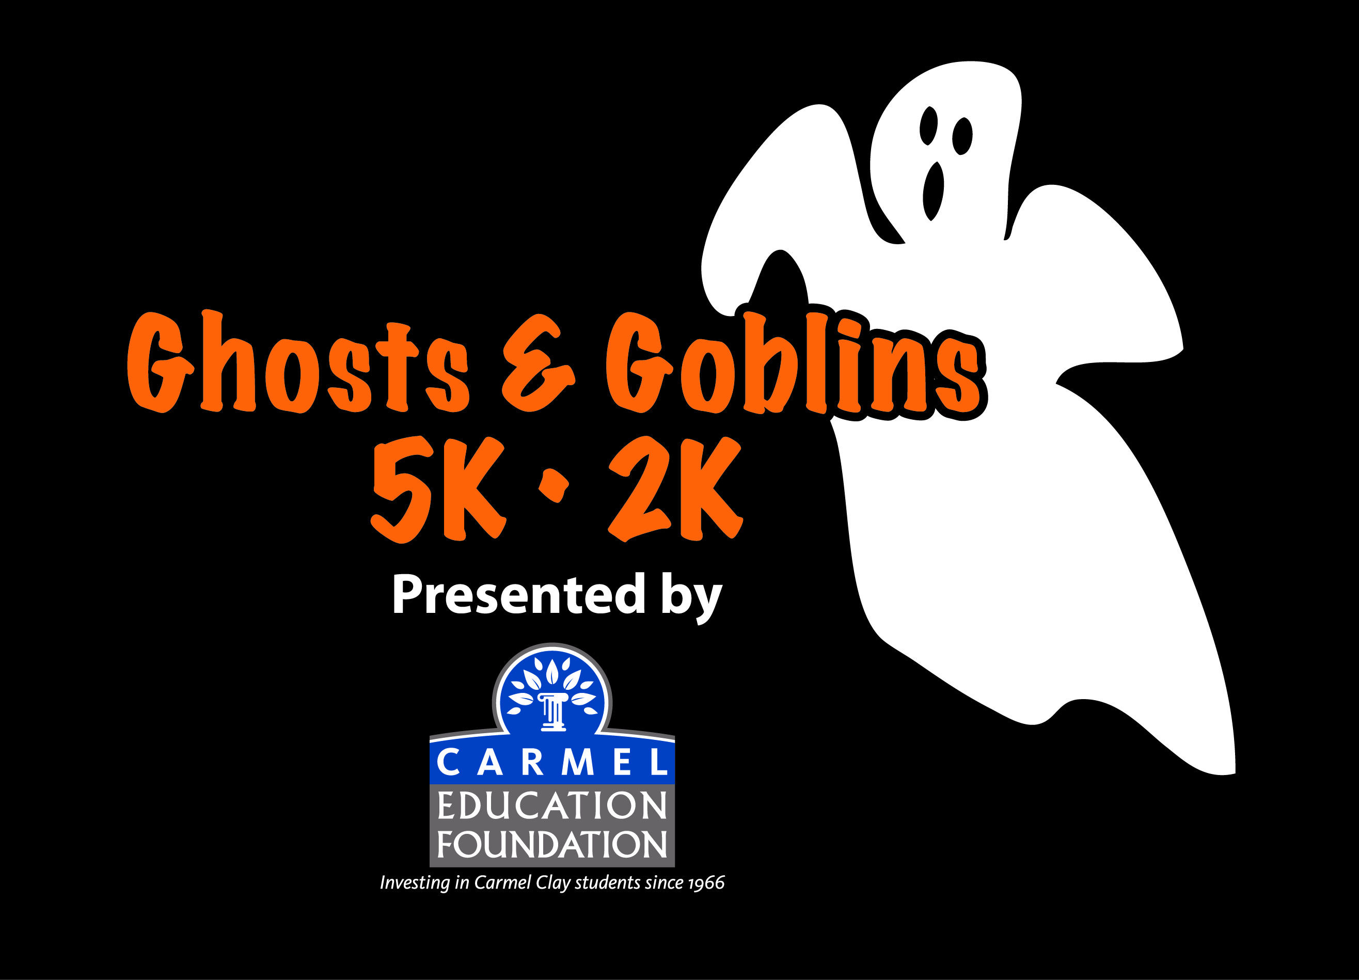
F A C T S H E E T
5K / 2K & CHS Wellness Fair
Presented by the Carmel Education Foundation (CEF)
Saturday, October 22, 2016

On-Line Registration (through Wednesday, October 19 at 11:59 p.m.): www.CarmelGhostRun.com

On-Site Registration & Packet Pickup:
Friday, October 21, 4:30 – 8:00 p.m. at Carmel High School Fieldhouse (Door 17)
Saturday, October 22, 7:00 – 8:00 a.m. at Carmel High School Fieldhouse (Door 17)

The 8th Annual Ghosts &Goblins 5K/2K & CHS Wellness Fair, presented by the Carmel Education Foundation, is a fundraising event to benefit the Carmel Clay schools through education grants. Founded in 1966, CEF invests in the academic excellence of the Carmel Clay Schools through grants to teachers for classroom enrichment and curriculum development.
General Information
Schedule:
Friday, October 21, 2016
On-Site 5K/2K Registration & Packet Pick-Up: 4:30 – 8:00 p.m.
5K / 2K participants can register and/or pick up pre-registration packets at Carmel High School Fieldhouse @
520 East Main Street, Carmel, Indiana. Fieldhouse is located on Northwest corner of CHS. Enter door #17.

Saturday, October 22, 2016
5K / 2K and Wellness Fair start and end at Carmel High School, 520 East Main Street, Carmel, Indiana. Free parking is available at Carmel High School, in front of the building, Carmel High School Stadium and Carmel Elementary School, 101 4th Ave, S.E., Carmel, Indiana.
Wellness Fair…………………………............................7:30 a.m. – 10:00 a.m.
On-Site 5K / 2K Registration & Packet Pick-up…..7:00 a.m. – 8:00 a.m.
5K Start……………………………………………………………..9:00 a.m.
2K Start……………………………………………………………..9:00 a.m.
2K Start behind 5K participants

5 K /2 K Participant Entry Fees:
Early Online Registration Online Registration Race Day
(Through 10/05/16) (Through 10/19/16) (10/21/16 and 10/22/16)
2K Run/Walk (Non Chipped)
Students* $10 $10 $15
Standard/Non-Student $20 $25 $30

2K Run/Walk (Chipped Time)
Students* $15 $15 $20
Standard/Non Student $20 $25 $30

5K Run/Walk (Chipped)
Student* $15 $15 $20
Standard/Non-Student $25 $30 $35

* Students under age 18 must have signed permission by a parent or guardian. Young children should be chaperoned by an adult. Children 4 and under are free.
Event Shirts not included in the price of registration:

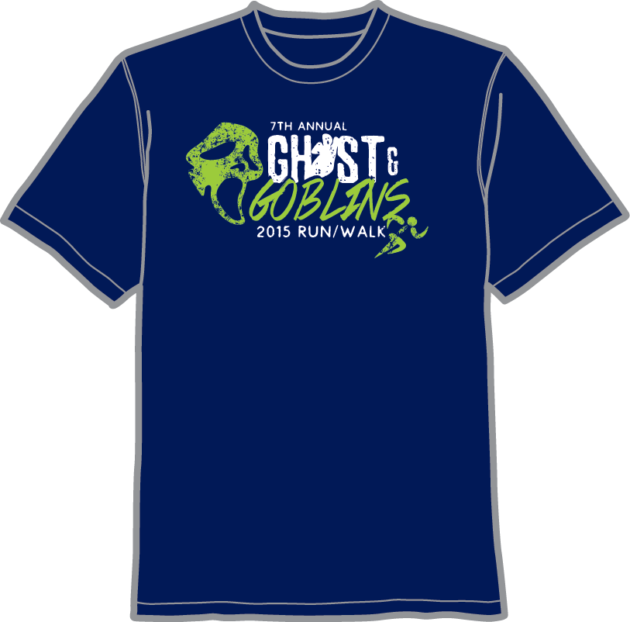

Event T-Shirt:
Short Sleeve: $10 Tech Long Sleeve and Sweatshirts are available on preregistration only.
Tech Long Sleeve: $15
Crew Sweatshirt: $22
Hooded Sweatshirt: $30

Timing and Runner Results
The event will be timed and scored. Complete timed results will be posted after the event on site and at www.CarmelGhostRun.com.

CEF Scholarship for Carmel High School Seniors Who Volunteer or Participate:
All Carmel High School seniors who enter either the 5K or 2K or who volunteers at the event will be eligible to apply for the Lisa Evans Scholarship.

Most Participants per CCS School:
The elementary school with the most participants will be awarded the Ghosts and Goblins Trophy, which the school will have to display for one year. The middle school with the most participants will be awarded the Ghosts and Goblins Banner, which the school may display permanently.

Costumes
Participants are encouraged to come in safe costumes, but masks are not allowed. Prizes will be awarded for best adult, youth, and ensemble costumes.

No pets are allowed in either the 2K or 5K except for service animals.

CHS Wellness Fair
A family wellness fair, organized by the Carmel High School Wellness Committee (Kim TenBrink, Chairperson), will be held in the CHS Fieldhouse from 7:30 to 10:00 a.m. The fair is free and open to the public.

Accessibility
The course for the 5K Run and 2K Walk are designed to be accessible for persons with special needs. Contact CEF at (317) 844-9961 x 2680 or foundation@ccs.k12.in.us for more information.

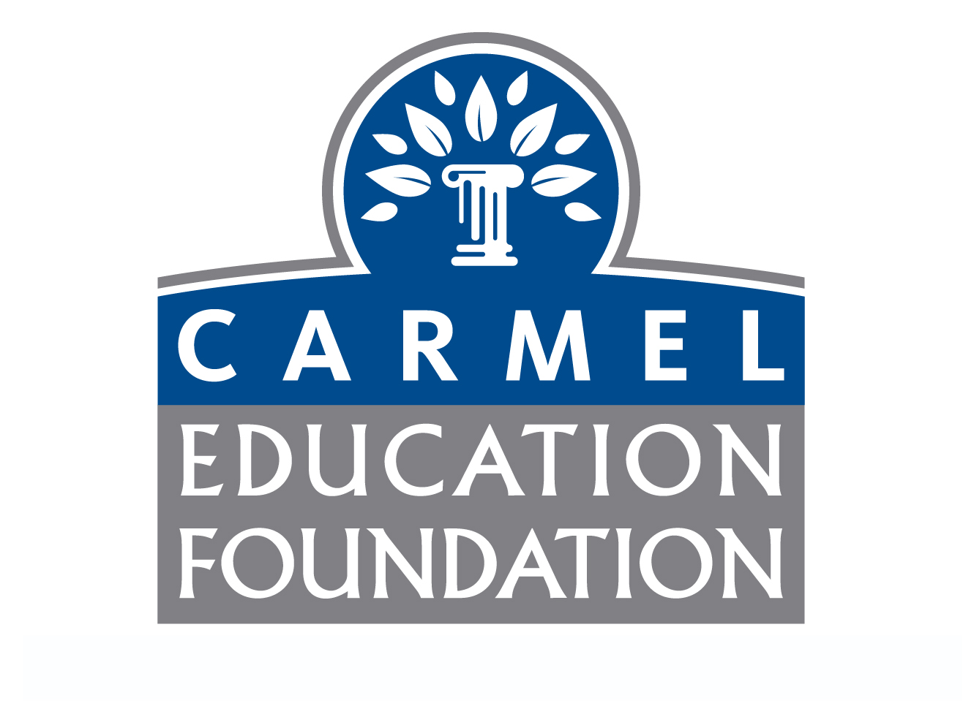
515 East Main St., Suite 124, Carmel, IN 46032 (317) 844-9961 x 2680
http://www1.ccs.k12.in.us/foundation/ghostsandgoblins
For more information, email foundation@ccs.k12.in.us.

